1. Using vi write your CV in the file mycv. Your CV should include your name, age, school, college, experience,...

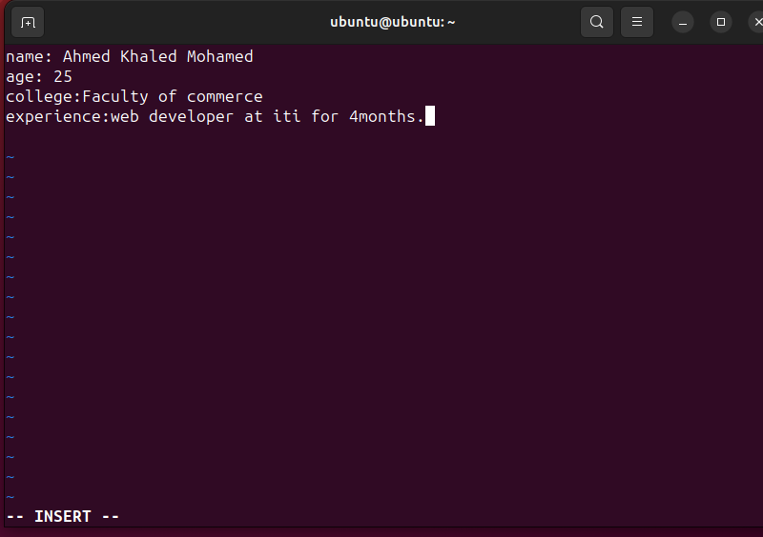

2. Open mycv file using vi command then: Without using arrows state how to:

to open mycv file : vi mycv

a. Move the cursor down one line at time.

j 🡺 command mode

b. Move the cursor up one line at time.

k 🡺 command mode

c. Search for word age

in last line mode :/age

d. Step to line 5 (assuming that you are in line 1 and file is more than 5 lines).

in command mode 🡺 5G

e. Delete the line you are on and line 5.

dd 🡺 command mode

5G

dd

f. How to step to the end of line and change to writing mode in one-step.

A 🡺 command mode

3. List the available shells in your system.

cat /etc/shells

4. List the environment variables in your current shell.

using command env or printenv

5. List all of the environment variables for the bash shell.

using man on bash then searching /shell variables :

man bash

/shell variables

6. What are the commands that list the value of a specific variable?

a. echo

b. printenv

7. Display your current shell name.

echo $SHELL

8. State the initialization files of: sh, ksh, bash.

Sh : /etc/profile

Ksh : ~/kshrc

Bash : /etc/profile, ~/.profile and ~/.bashrc

9. Edit in your profile to display date at login and change your prompt permanently.

to display date : vi ~/.bashrc then add date to the file.

to change prompt permanently: vi ~/.bashrc then add PS1=”new prompt name”

10. Execute the following command :

echo \ then press enter

What is the purpose of \ ?

Notice the prompt ”>” what is that? and how can you change it from “>” to “:”.

it indicates a line continuation and to move from the “>” to “:” you can just continue the echo script like ($PATH) or press enter to move to new line in the terminal

11. Create a Bash shell alias named ls for the “ls –l” command

alias ls=”ls -l”